OpenEuler RISC-V Xfce安装测试

Ubuntu20

中科大镜像站

<https://iso.mirrors.ustc.edu.cn/ubuntu-releases/jammy/ubuntu-22.04-desktop-amd64.iso>

官网

<https://releases.ubuntu.com/22.04/ubuntu-22.04-desktop-amd64.iso>

默认配置安装即可

# 一、配置apt源

文件备份

sudo cp /etc/apt/sources.list /etc/apt/sources.list.bak

编辑源文件

sudo gedit /etc/apt/sources.list

下面内容覆盖原内容，保存

deb http://mirrors.tuna.tsinghua.edu.cn/ubuntu/ focal main restricted

deb http://mirrors.tuna.tsinghua.edu.cn/ubuntu/ focal-updates main restricted

deb http://mirrors.tuna.tsinghua.edu.cn/ubuntu/ focal universe

deb http://mirrors.tuna.tsinghua.edu.cn/ubuntu/ focal-updates universe

deb http://mirrors.tuna.tsinghua.edu.cn/ubuntu/ focal multiverse

deb http://mirrors.tuna.tsinghua.edu.cn/ubuntu/ focal-updates multiverse

deb http://mirrors.tuna.tsinghua.edu.cn/ubuntu/ focal-backports main restricted universe multiverse

deb http://mirrors.tuna.tsinghua.edu.cn/ubuntu/ focal-security main restricted

deb http://mirrors.tuna.tsinghua.edu.cn/ubuntu/ focal-security universe

deb http://mirrors.tuna.tsinghua.edu.cn/ubuntu/ focal-security multiverse

保存后执行

sudo apt update

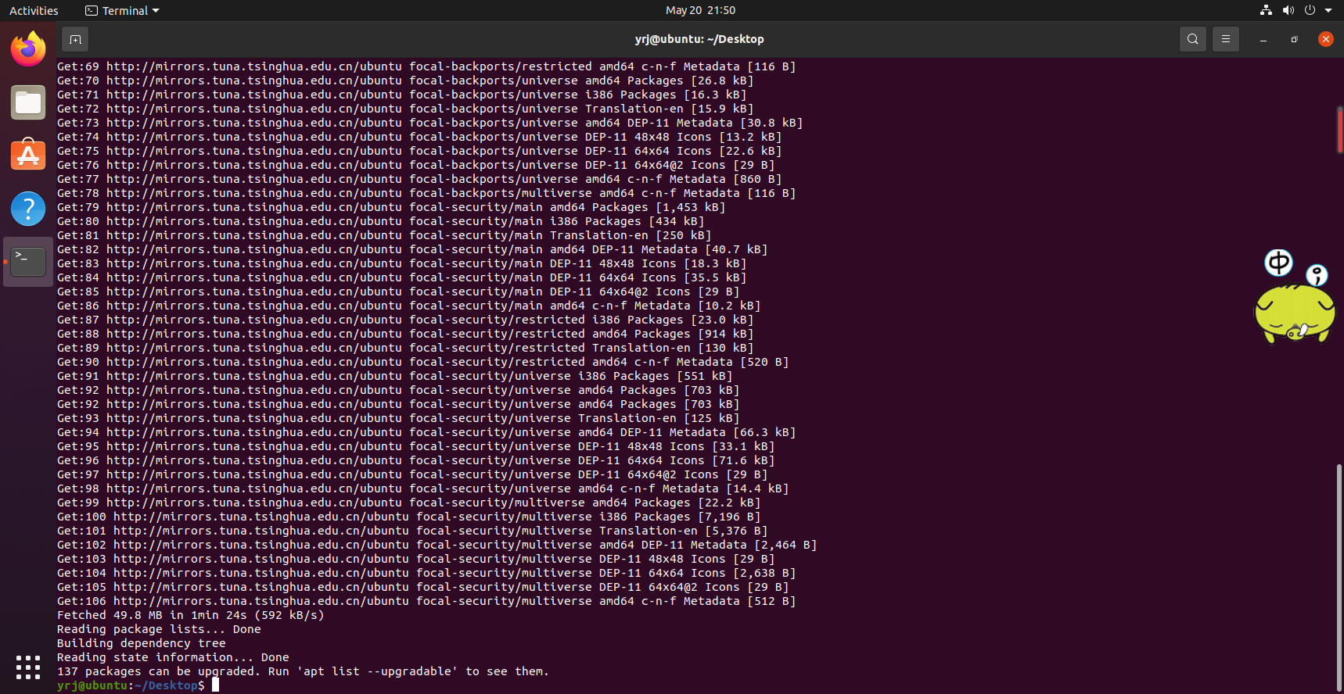

# 二、安装阶段

* 安装必要的构建工具

sudo apt install build-essential autoconf automake autotools-dev pkg-config bc curl gawk git bison flex texinfo gperf libtool patchutils mingw-w64 libmpc-dev libmpfr-dev libgmp-dev libexpat-dev libfdt-dev zlib1g-dev libglib2.0-dev libpixman-1-dev libncurses5-dev libncursesw5-dev meson libvirglrenderer-dev libsdl2-dev -y

sudo add-apt-repository ppa:deadsnakes/ppa

sudo apt install python3.9 python3-pip -y

sudo apt install -f

pip3 install meson

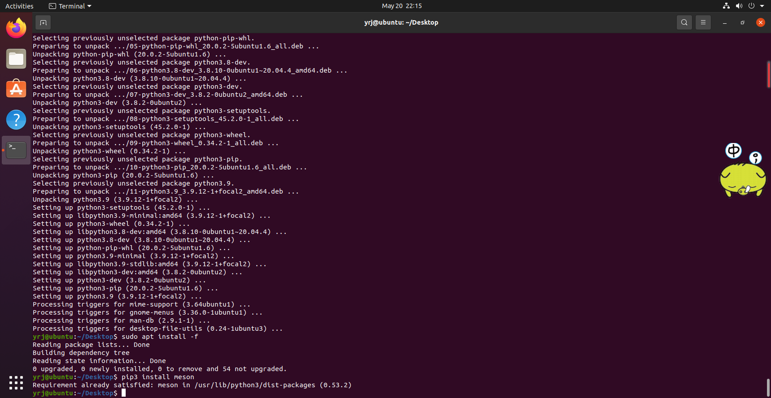

* 下载支持视频输出QEMU源码包

命令格式如下（需要申请gitee账号）

git clone -b display <https://gitlab.com/wangjunqiang/qemu.git>

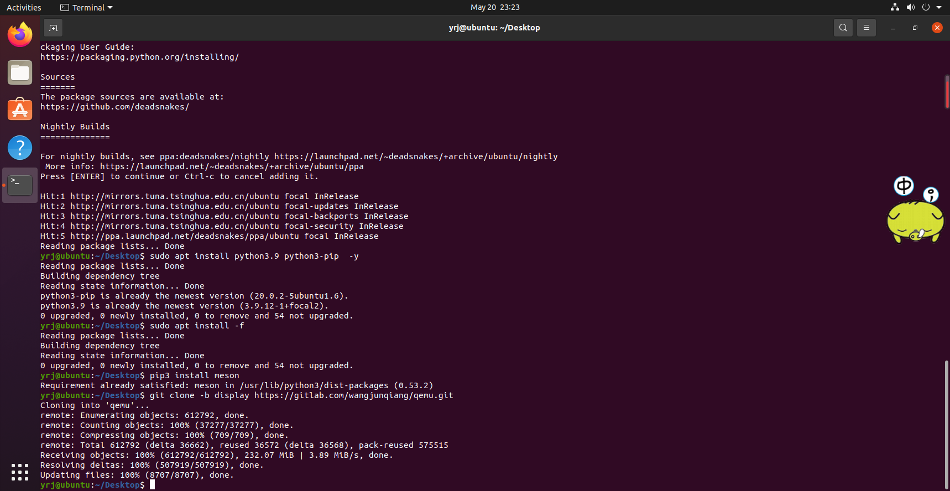

cd qemu

git submodule init

git submodule update –recursive

mkdir build

cd build

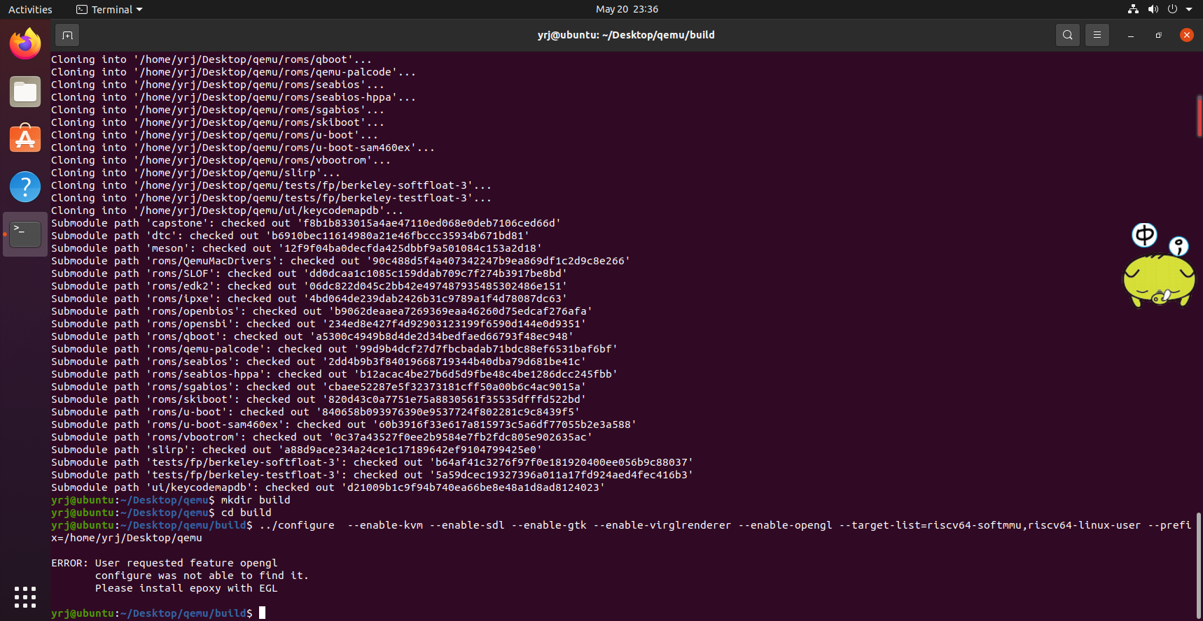

* 配置riscv64-qemu

以下命令中xbot为用户目录名

../configure --enable-kvm --enable-sdl --enable-gtk --enable-virglrenderer --enable-opengl --target-list=riscv64-softmmu,riscv64-linux-user --prefix=/home/wzq/Desktop/qemu

riscv-64-linux-user为用户模式，可以运行基于 RISC-V 指令集编译的程序文件, softmmu为镜像模拟器，可以运行基于 RISC-V 指令集编译的Linux镜像，为了测试方便，可以两个都安装

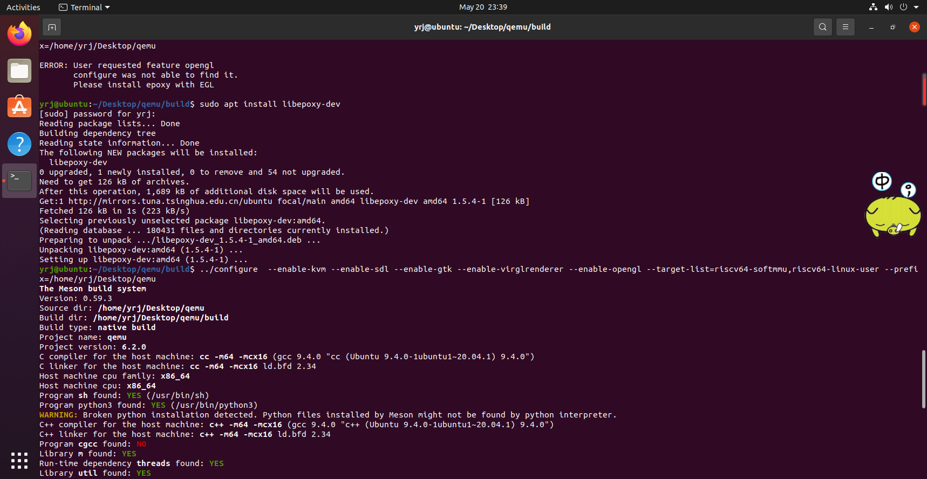

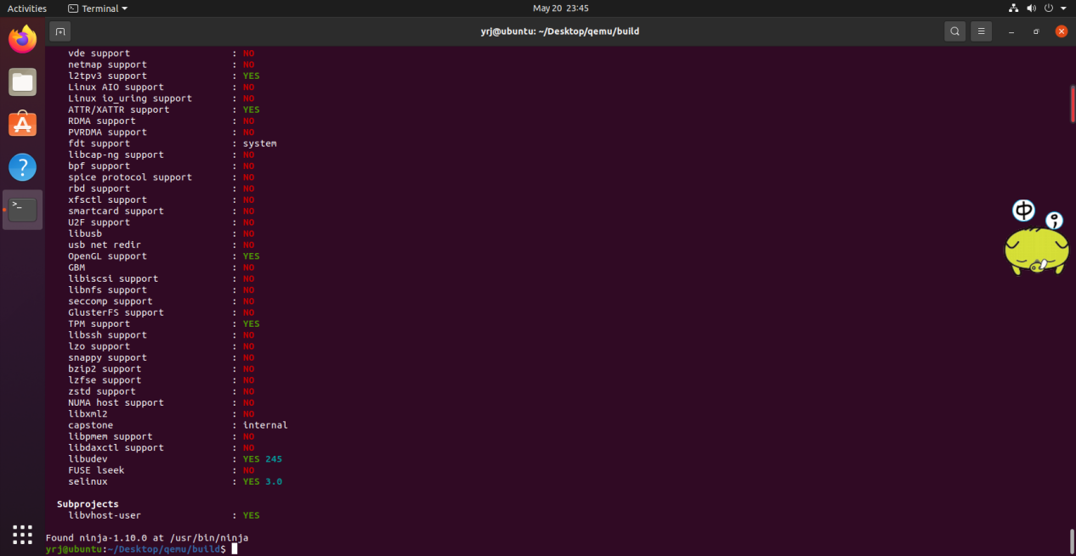

* 编译

make -j $(nproc)

make install

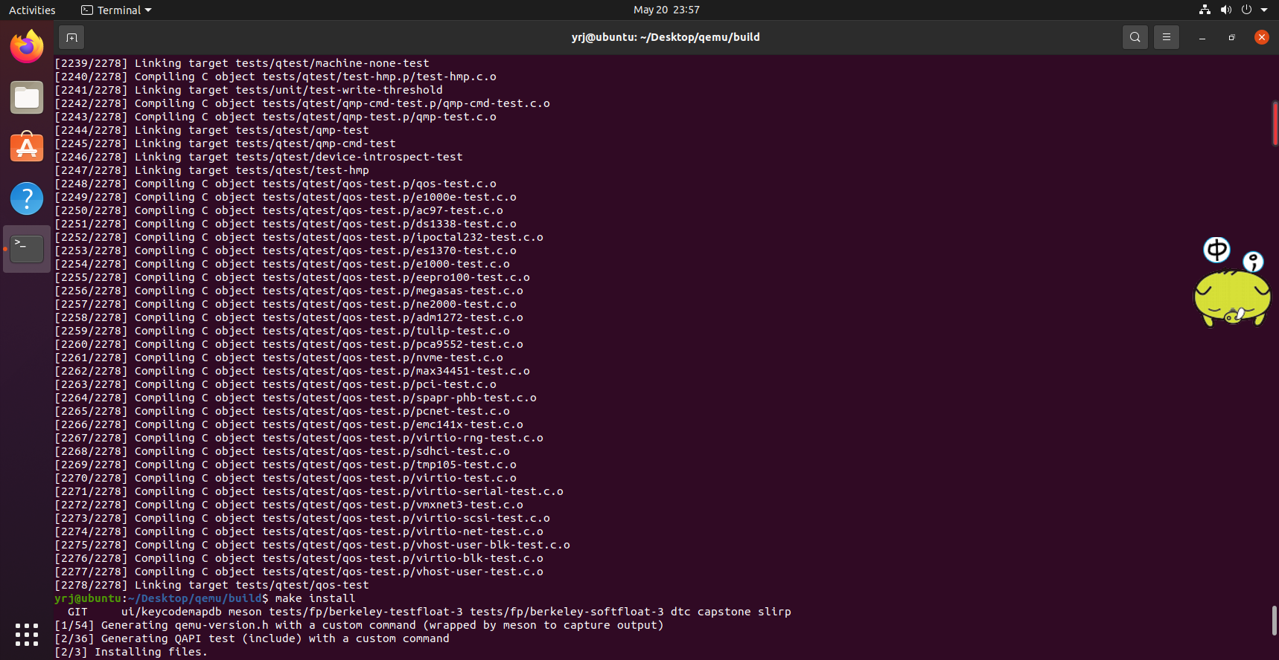

##### Ubuntu上配置环境变量

在环境变量PATH中添加riscv64-qemu所在目录，使相关命令可以直接使用

vim ~/.bashrc

~/.bashrc文末添加

export QEMU_HOME=/home/wzq/Desktop/qemu

export PATH=$QEMU_HOME/bin:$PATH

**注意一定要将**QEMU_HOME**路径替换为**--prefix**定义的路径**

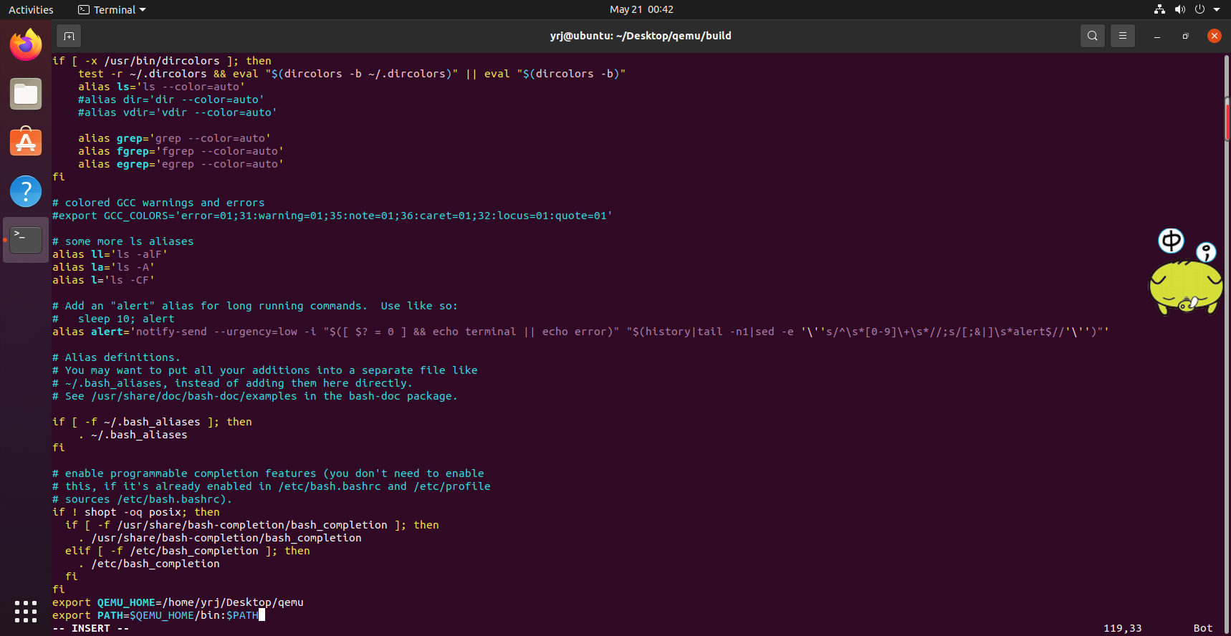

检查是否添加成功

source ~/.bashrc

echo $PATH

屏幕回显包含/home/xbot/program/riscv64-qemu

/home/xbot/program/riscv64-qemu/bin:/usr/local/sbin:/usr/local/bin:/usr/sbin:/usr/bin:/sbin:/bin:/snap/bin



##### 验证安装是否正确

qemu-system-riscv64 --version

如出现类似如下输出表示 QEMU 工作正常

QEMU emulator version 6.2.90 (v7.0.0-rc0-40-g2058fdbe81)

Copyright (c) 2003-2022 Fabrice Bellard and the QEMU Project developers

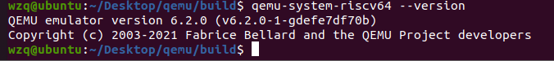

## 下载 openEuler RISC-V 系统镜像

### 2.1 下载 编译支持视频输出的 kernel

<https://gitee.com/yunxiangluo/riscv-openeuler/raw/master/chapter3/class1/Image>

建议git clone或zip下载后放入目录

git clone https://gitee.com/yunxiangluo/riscv-openeuler.git

cp ./riscv-openeuler/chapter3/class1/Image .

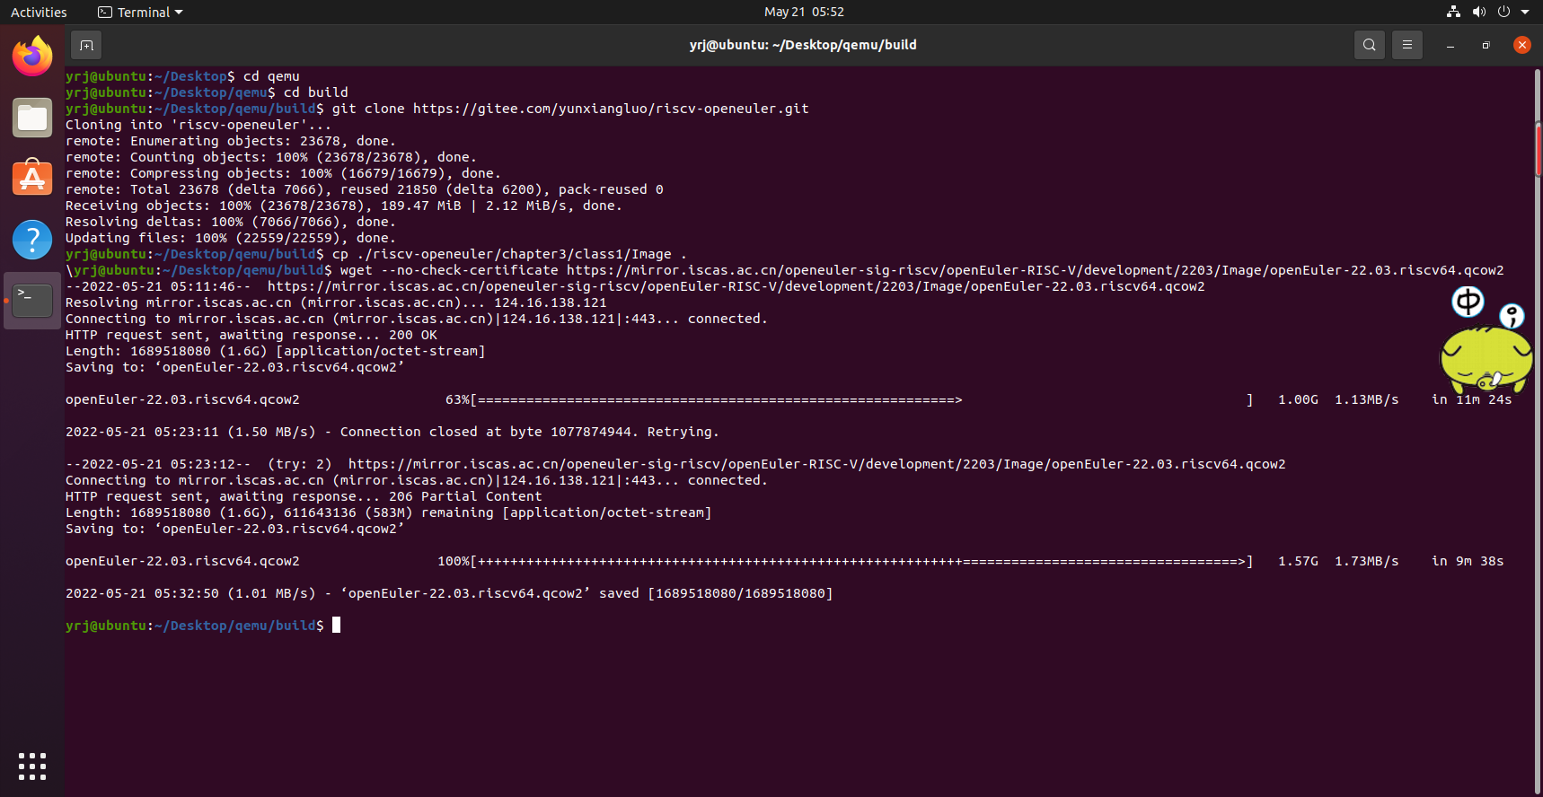

### 2.2 下载 openeuler risc-v 文件系统

<https://mirror.iscas.ac.cn/openeuler-sig-riscv/openEuler-RISC-V/development/2203/Image/openEuler-22.03.riscv64.qcow2>

wget --no-check-certificate https://mirror.iscas.ac.cn/openeuler-sig-riscv/openEuler-RISC-V/development/2203/Image/openEuler-22.03.riscv64.qcow2



## QEMU启动RISC-V openEuler

qemu-system-riscv64 \

-nographic -machine virt \

-smp 8 -m 4G \

-display sdl -vga std \

-kernel Image \

-append "loglevel=3 swiotlb=1 console=ttyS0 rw root=/dev/vda1" \

-drive file=openEuler-22.03.riscv64.qcow2,format=qcow2,id=hd0 \

-object rng-random,filename=/dev/urandom,id=rng0 \

-device virtio-rng-device,rng=rng0 \

-device virtio-blk-device,drive=hd0 \

-device virtio-net-device,netdev=usernet \

-netdev user,id=usernet,hostfwd=tcp::12055-:22 \

-device qemu-xhci -device usb-tablet -device usb-kbd

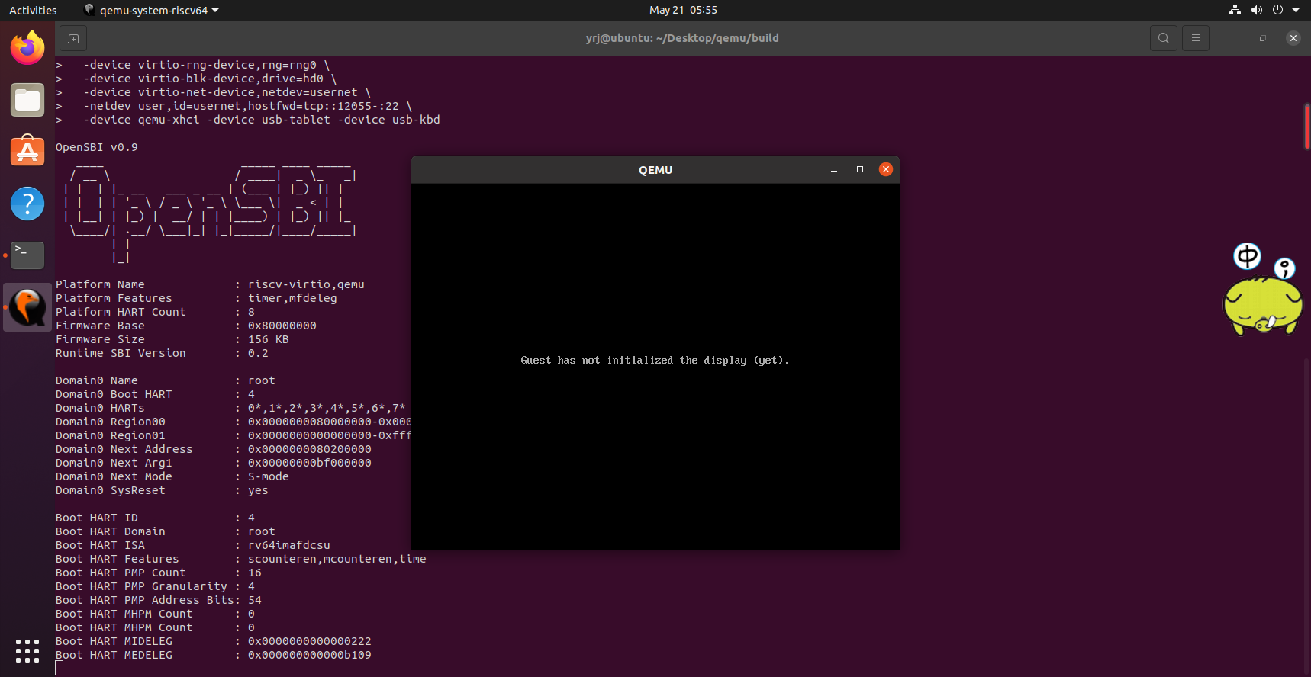

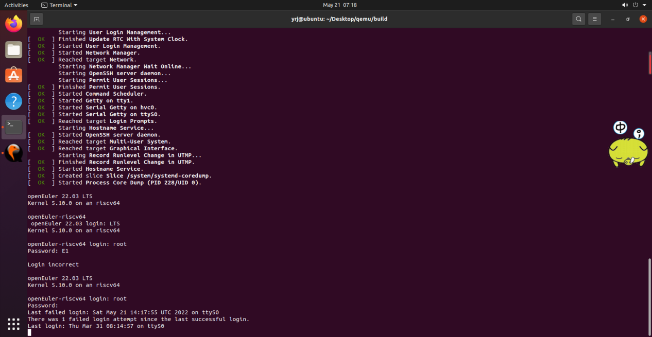

### 添加xfce软件源

vim /etc/yum.repos.d/openEuler.repo

**[22.03]**

**name**=22.03

**baseurl**=http://obs-backend.tarsier-infra.com:82/openEuler:/22.03/openEuler_2203/

**enabled**=1

**gpgcheck**=0

**[22.03Epol]**

**name**=22.03Epol

**baseurl**=http://obs-backend.tarsier-infra.com:82/openEuler:/22.03:/Epol/openEuler_22.03_Epol/

**enabled**=1

**gpgcheck**=0

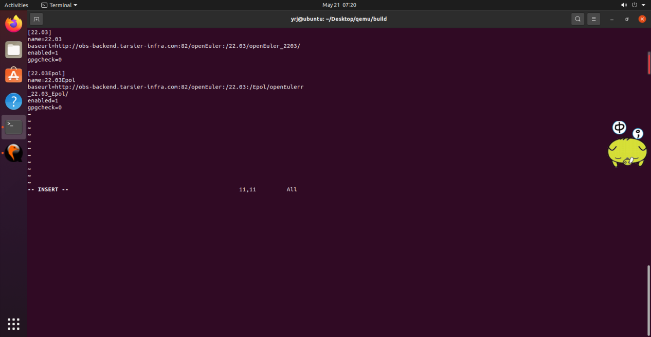

yum install libxfce4util xfconf libxfce4ui exo garcon thunar thunar-volman tumbler xfce4-appfinder xfce4-panel xfce4-power-manager xfce4-settings xfdesktop xfwm4 xfce4-session xfce4-terminal –y

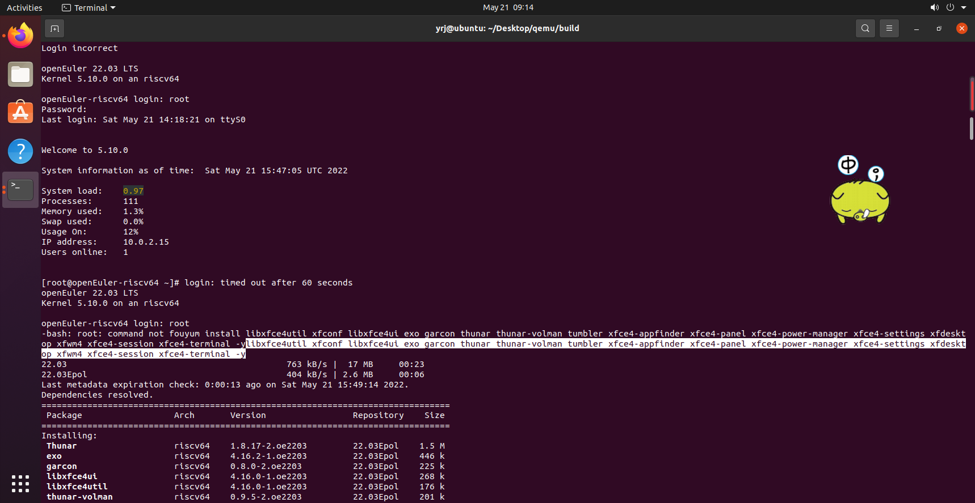

再安装 xorg 的软件包 xorg-x11-xinit 和 xorg-x11-server。

yum install xorg-x11-xinit xorg-x11-server -y

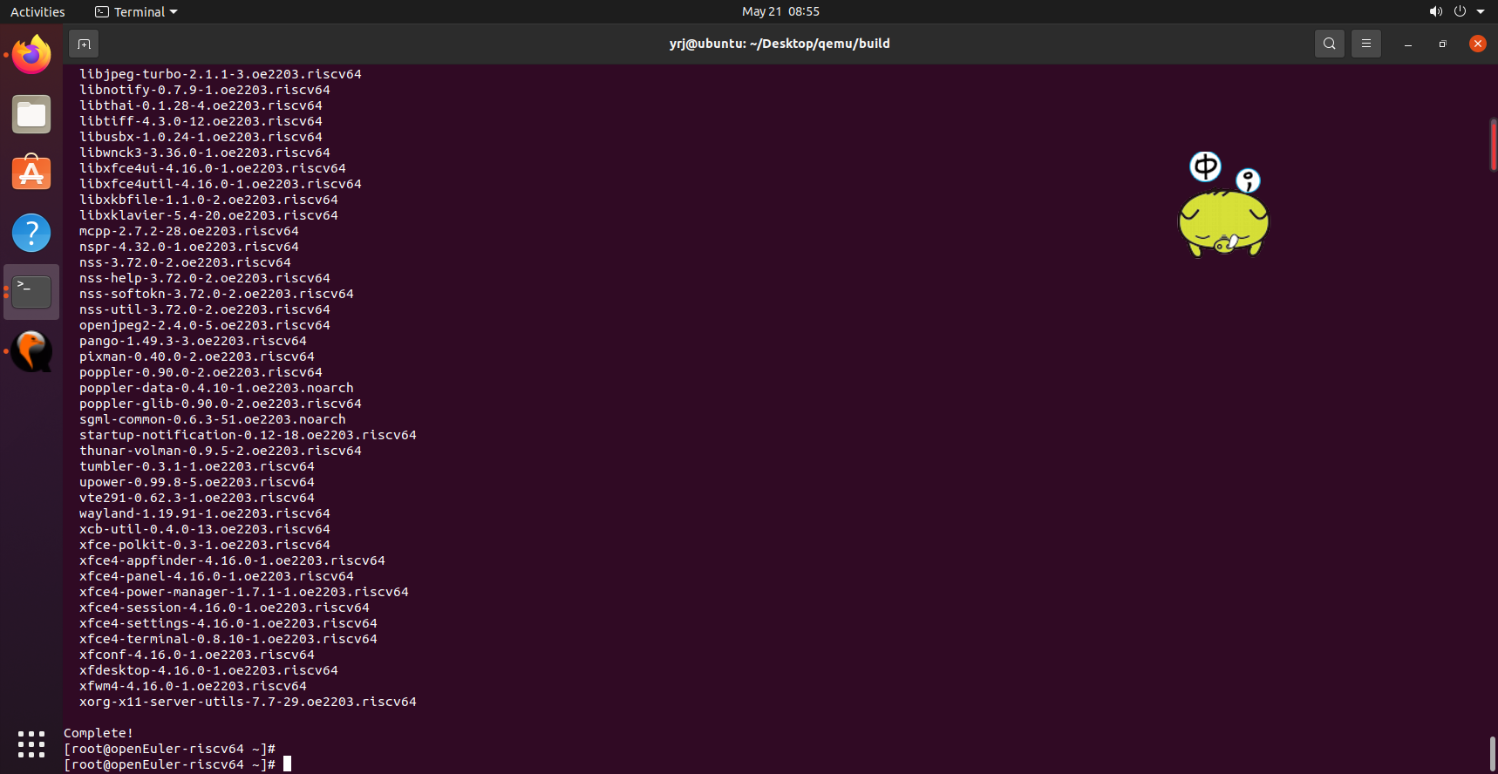

yum update glib2

